**Title:** [Your Paper Title]

**Authors:** [Author(s) Full Name(s) and Affiliation(s)]

**Abstract:**

**Objective:** [Briefly state the main goal or aim of your research. What specific problem or challenge does your research address in the context of Industry 5.0 and Artificial Intelligence?]

**Methods:** [Describe the methodology or approach used in your research. Mention any innovative techniques, tools, or frameworks employed, particularly about Industry 5.0 topics such as Big Data, Blockchain, IoT, Robotics, etc.]

**Results:** [Summarize the key findings or results of your research. How do these findings contribute to the field of Industry 5.0 and Artificial Intelligence?]

**Implications:** [Discuss the implications of your findings. How do they advance current knowledge or practices in your field? What potential applications or benefits do they offer for industry and academia?]

**Keywords:** [List 3-5 keywords that represent the main topics of your research. For example, Blockchain, Deep Learning, IoT, Industry 5.0.]

**Example:**

**Title:** Optimizing Energy Efficiency in Smart Homes Using Blockchain and Deep Reinforcement Learning

**Authors:** Sami Ben Slama, King Abdulaziz University, Saudi Arabia

**Abstract:**

**Objective:** This study aims to enhance energy efficiency in smart homes by integrating blockchain technology with Deep Reinforcement Learning (DRL). The focus is on developing a robust system for managing energy distribution and trading among residential users.

**Methods:** We propose a novel approach that combines blockchain for secure, transparent transactions with DRL algorithms for dynamic energy management. The system utilizes real-time data from IoT sensors and historical usage patterns to optimize energy exchange and pricing.

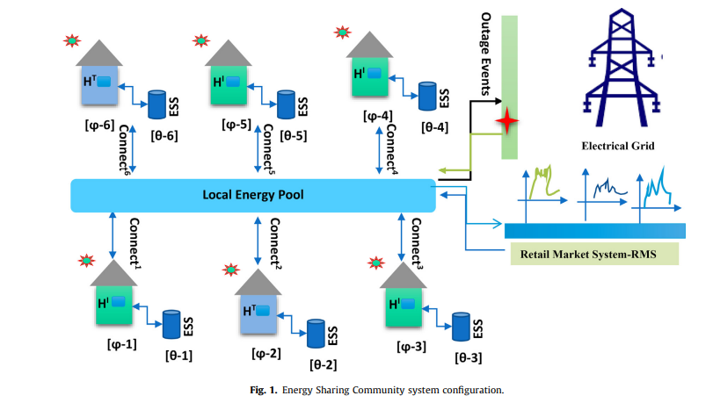

**Results:** Our experiments demonstrate significant improvements in energy efficiency and cost reduction. The proposed system effectively balances energy supply and demand, providing real-time adjustments based on user behavior and external conditions.

**Implications:** The integration of blockchain and DRL in smart home energy management offers a scalable solution for enhancing energy efficiency. This approach has potential applications in residential energy trading, contributing to more sustainable and cost-effective energy systems.

**Keywords:** Blockchain, Deep Reinforcement Learning, Smart Homes, Energy Efficiency, IoT